
MOHAN BABU UNIVERSITY
Sree Sainath Nagar, Tirupati, Andhra Pradesh 517102, India.
www.mbu.asia
Report for (Nature of event like workshop/ conference/seminar...)_ organized / participated

Name of the Faculty :
School & Department : |  | Designation :
Mode of Event : (Online / Offline/ Hybrid)
Name of the Event :
Level : International / National / State / Regional / Industry / University ..
UN SDGs Mapped with Event Team :
No poverty (SDG 1), Zero hunger (SDG 2), Good health and well-being (SDG 3), Quality education (SDG 4), Gender equality (SDG 5), Clean water and sanitation (SDG 6), Affordable and clean energy (SDG 7), Decent work and economic growth (SDG 8), Industry, innovation and infrastructure (SDG 9), Reduced inequalities (SDG 10), Sustainable cities and communities (SDG 11), Responsible consumption and production (SDG 12), Climate action (SDG 13), Life below water (SDG 14), Life on land (SDG 15), Peace, justice, and strong institutions (SDG 16), and Partnerships for the goals (SDG 17).
Venue :
No. of Days : |  | Dates :
Funded by : UGC / CSIR / DST / DSIR /ICSSR /NCERT /INSA/ Management etc
Details of Collaboration if any :
No. of Participants : | Registration charges (if any) :
Resource Person(s) Details:

Name
Designation
Department
Intuition/ industry
City
State
Country

Brief Report

Outcome :
Focusing & Choices (1. Academic Related, 2. Research Related 3. Extension Related &
4. SDG)

Brief how this event / activity is in line with Sustainable Development Goals (SDGs) attributed:
Remarks and Feedback on the Event :
(Summary of the Feedback - As per IQAC format - Enclosed)
Plan of Implementing in MBU (if any) :
Submission Check List : Approval Letter Budget & Statement of Expenditure

Signature of the Faculty HoD

Dean
Event Brochure & Invitation:
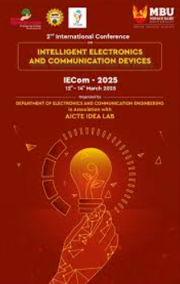
Photographs  (Geo Tagged- Use Timemark App) | (1. Inauguration Photo, 2. Event Photos & 3. Valedictory Photo)

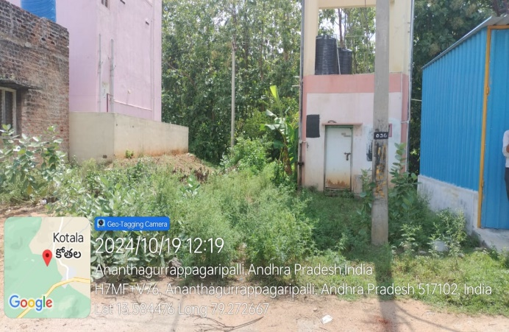 | 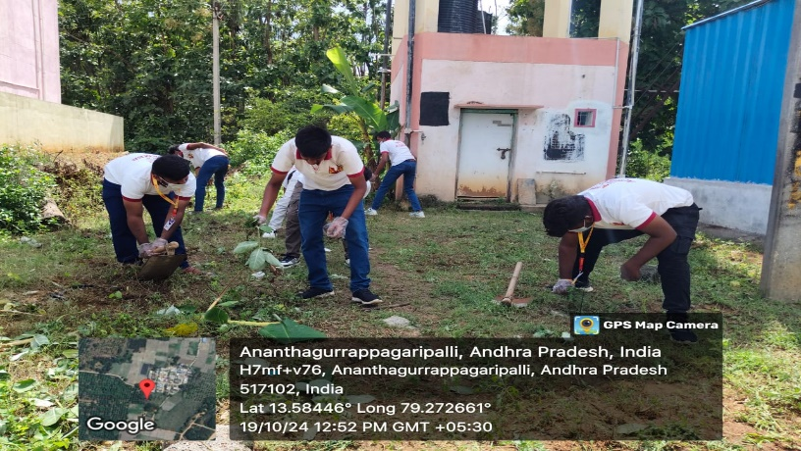
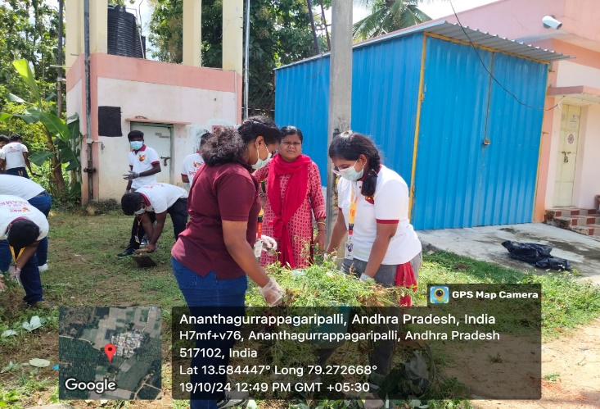 | 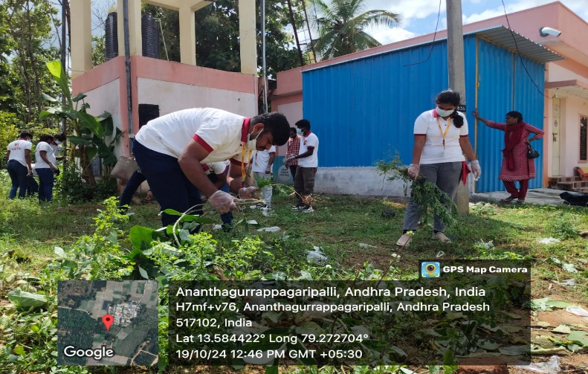
Copy of the Participation & Resource Person(s) Certificate:

Encl: 1. List of Participants and Signed Attendance Copy (for both FN and AN Sections)
2. Feedback (Resource Person, Participant’s & Organizer)

